# EMBEDDED SYSTEMS

System

A system is an arrangement in which all its unit assemble work together according to a set of rules. It can also be defined as a way of working, organizing or doing one or many tasks according to a fixed plan. For example, a watch is a time displaying system. Its components follow a set of rules to show time. If one of its parts fails, the watch will stop working. So we can say, in a system, all its subcomponents depend on each other.

**Embedded System**

As its name suggests, Embedded means something that is attached to another thing. An embedded system can be thought of as a computer hardware system having software embedded in it. An embedded system can be an independent system or it can be a part of a large system. An embedded system is a microcontroller or microprocessor based system which is designed to perform a specific task. For example, a fire alarm is an embedded system; it will sense only smoke. An embedded system is an electronic system that has a software and  is embedded in computer hardware. It is programmable or non- programmable depending on the application. An Embedded system is defined as a way of working, organizing, performing single or multiple tasks according to a set of rules.In an embedded system, all the units assemble and work together according to the program. Examples of embedded systems include numerous products such as microwave ovens, washing machine, printers, automobiles, cameras, etc. These systems use microprocessors, microcontrollers as well as processors like DSPs. This article gives an overview of what is an embedded system and types of embedded system.

## What is an embedded system?

An Embedded system is a combination of computer hardware and software. As with any electronic system, this system requires a hardware platform and that is built with a microprocessor or [microcontroller](http://en.wikipedia.org/wiki/Microcontroller" \t "_blank).The Embedded system hardware includes elements like user interface, Input/Output interfaces, display and memory, etc.Generally, an embedded system comprises power supply, processor, memory, timers, serial  communication ports and system application specific circuits.

[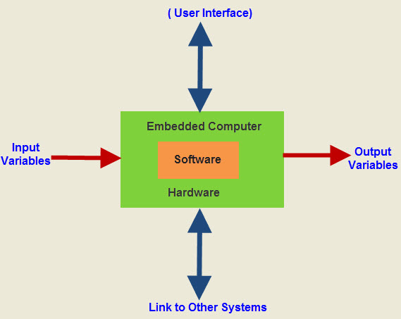](http://www.efxkits.us/wp-content/uploads/2014/10/Embedded-Systemssss.jpg)

**Embedded System**

Embedded system software is written in a high-level language, and then compiled to achieve a specific function within a non-volatile memory in the hardware. Embedded system software is designed to keep in view of three limits. They are availability of system memory and processor speed. When the system runs endlessly, there is a need to limit the power dissipation for events like run, stop and wake up.

An embedded system has three components −

* It has hardware.
* It has application software.
* It has Real Time Operating system (RTOS) that supervises the application software and provide mechanism to let the processor run a process as per scheduling by following a plan to control the latencies. RTOS defines the way the system works. It sets the rules during the execution of application program. A small scale embedded system may not have RTOS.

So we can define an embedded system as a Microcontroller based, software driven, reliable, real-time control system.

**Characteristics of an Embedded System**

* **Single-functioned** − An embedded system usually performs a specialized operation and does the same repeatedly. For example: A pager always functions as a pager.
* **Tightly constrained** − All computing systems have constraints on design metrics, but those on an embedded system can be especially tight. Design metrics is a measure of an implementation's features such as its cost, size, power, and performance. It must be of a size to fit on a single chip, must perform fast enough to process data in real time and consume minimum power to extend battery life.
* **Reactive and Real time** − Many embedded systems must continually react to changes in the system's environment and must compute certain results in real time without any delay. Consider an example of a car cruise controller; it continually monitors and reacts to speed and brake sensors. It must compute acceleration or de-accelerations repeatedly within a limited time; a delayed computation can result in failure to control of the car.
* **Microprocessors based** − It must be microprocessor or microcontroller based.
* **Memory** − It must have a memory, as its software usually embeds in ROM. It does not need any secondary memories in the computer.
* **Connected** − It must have connected peripherals to connect input and output devices.
* **HW-SW systems** − Software is used for more features and flexibility. Hardware is used for performance and security.

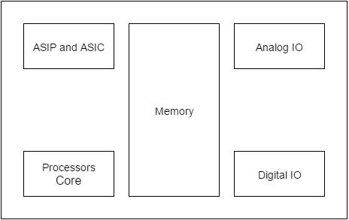

Advantages

* Easily Customizable
* Low power consumption
* Low cost
* Enhanced performance

Disadvantages

* High development effort
* Larger time to market

Basic Structure of an Embedded System

The following illustration shows the basic structure of an embedded system −

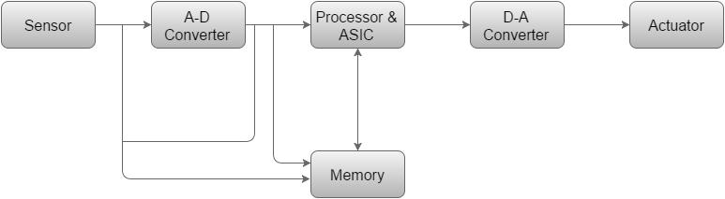

* **Sensor** − It measures the physical quantity and converts it to an electrical signal which can be read by an observer or by any electronic instrument like an A2D converter. A sensor stores the measured quantity to the memory.
* **A-D Converter** − An analog-to-digital converter converts the analog signal sent by the sensor into a digital signal.
* **Processor & ASICs** − Processors process the data to measure the output and store it to the memory.
* **D-A Converter** − A digital-to-analog converter converts the digital data fed by the processor to analog data
* **Actuator** − An actuator compares the output given by the D-A Converter to the actual (expected) output stored in it and stores the approved output.

Buy Electronic Kits & Electrical Projects in California, Florida, Georgia, New Jersey, New Mexico, New York, Ohio, Texas, Washington and the rest of United States.

### TYPES OF EMBEDDED SYSTEMS

Embedded systems can be classified into different types based on performance, functional requirements and performance of the microcontroller.

[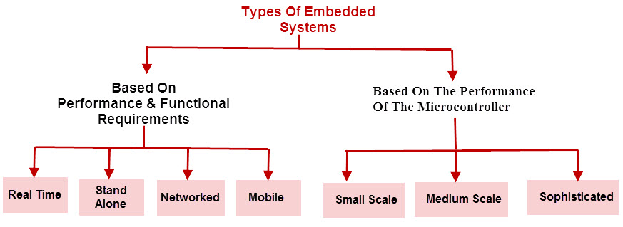](http://www.efxkits.us/wp-content/uploads/2014/10/Types-of-Embedded-systems.jpg)

**Types of Embedded systems**

Embedded systems are classified into four categories based on their performance and functional requirements:

* Stand alone embedded systems
* Real time embedded systems
* Networked embedded systems
* Mobile embedded systems

Embedded Systems are classified into three types based on the performance of the microcontroller such as

* Small scale embedded systems
* Medium scale embedded systems
* Sophisticated embedded systems

#### **Stand Alone Embedded Systems**

Stand alone embedded systems do not require a host system like a computer, it works by itself. It takes the input from the input ports either analog or digital and processes, calculates and converts the data and gives the resulting data through the connected device-Which either controls, drives and displays the connected devices. Examples for the stand alone embedded systems are mp3 players, digital cameras, video game consoles, microwave ovens and temperature measurement systems.

#### **Real Time Embedded Systems**

A real time embedded system is defined as, a system which gives a required o/p in a particular time. These types of embedded systems follow the time deadlines for completion of a task. Real time embedded systems are classified into two types such as soft and hard real time systems.

#### **Networked Embedded Systems**

These types of embedded systems are related to a network to access the resources. The connected network can be LAN, WAN or the internet. The connection can be any wired or wireless. This type of embedded system is the fastest growing area in embedded system applications. The embedded web server is a type of system wherein all embedded devices are connected to a web server and accessed and controlled by a web browser. Example for the LAN networked embedded system is a home security system wherein all sensors are connected and run on the protocol TCP/IP

#### **Mobile Embedded Systems**

Mobile embedded systems are used in portable embedded devices like cell phones, mobiles, digital cameras, mp3 players and personal digital assistants, etc.The basic limitation of these devices is the other resources and limitation of memory.

#### **Small Scale Embedded Systems**

These types of embedded systems are designed with a single 8 or 16-bit microcontroller that may even be activated by a battery. For developing embedded software for small scale embedded systems, the main programming tools are an editor, assembler, cross assembler and integrated development environment (IDE).

#### **Medium Scale Embedded Systems**

These types of embedded systems design with a single or 16 or 32 bit microcontroller, RISCs or DSPs. These types of embedded systems have both hardware and software complexities. For developing embedded software for medium scale embedded systems, the main programming tools are C, C++, JAVA, Visual C++, RTOS, debugger, source code engineering tool, simulator and IDE.

#### **Sophisticated Embedded Systems**

These types of embedded systems have enormous hardware and software complexities that may need ASIPs, IPs, PLAs, scalable or configurable processors. They are used for cutting-edge applications that need hardware and software Co-design and components which have to assemble in the final system.

### Applications of Embedded Systems:

Embedded systems are used in different applications like automobiles, telecommunications, smart cards, missiles, satellites, computer networking and digital consumer electronics.

[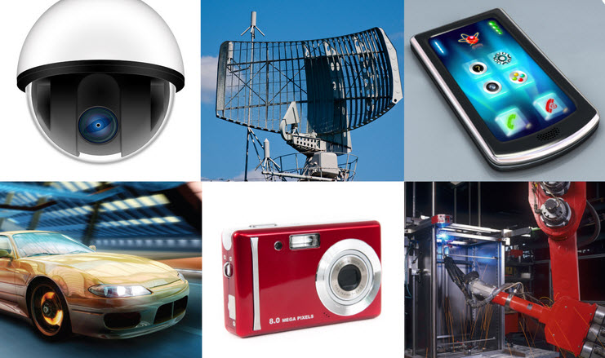](http://www.efxkits.us/wp-content/uploads/2014/10/Applications.jpg)

**Applications of Embedded Systems**

**Embedded Systems in Automobiles and in telecommunications**

* Motor and cruise control system
* Body or Engine safety
* Entertainment and multimedia in car
* E-Com and Mobile access
* Robotics in assembly line
* [Wireless communication](http://www.efxkits.us/project-kits-on-wireless-communication-for-electronics-professionals/)
* Mobile computing and networking

**Embedded Systems in Smart Cards, Missiles and Satellites**

* Security systems
* Telephone and banking
* Defense and aerospace
* Communication

**Embedded Systems in Peripherals  & Computer Networking**

* Displays and Monitors
* Networking Systems
* Image Processing
* Network cards and printers

**Embedded Systems in Consumer Electronics**

* Digital Cameras
* Set top Boxes
* High Definition TVs
* DVDs

This is all about the embedded systems, types of embedded systems with their applications. We all know that these systems are extremely fabulous systems that play a vital role in many devices, equipment’s, industrial control systems, industrial instrumentation and home appliances irrespective of circuit complexity. Considering the huge significance of embedded systems, this embedded systems article deserves readers’ feedback, queries, suggestions and comments. Furthermore, for any queries regarding electronics project [kits,](http://www.efxkits.us/get-a-chance-to-win-free-electronics-project-kits-by-edgefxkits/)readers can post their comments in the comment section below.